Report of Fellowship Week 1

Submitted by: Ahmed Hassan

## Key Metrics Details & Introduction

The DS Fellowship 1 Feedback Dashboard compiles participant feedback, including demographics, ratings, preferences, and key insights. The data is current as of September 05, 2025, and is visualized in Monday.com.

The purpose of this dashboard is to evaluate the program's effectiveness, highlight its strengths, identify areas for improvement, and inform future iterations through interactive visualizations. Key metrics include:

* **Geographic Distribution and Demographics**: Most of the participants are from Pakistan (91.7%), while 8.3% are from Nigeria. Within Pakistan, the highest number of participants are from Islamabad. The fellowship is heavily male-dominated, with males making up 83.3% of participants and females at 16.7%.
* **Student Understanding and Satisfaction**: The majority of participants (58.3%) found the material to be "Very clearly" understood, while 41.7% understood it "Somewhat clear". All participants (100%) reported benefiting from the learning activities.
* **Student Background**: The dashboard includes data on the academic and professional backgrounds of the students. The data shows a mix of backgrounds, including Computer, Civil Engineering, Informatics, Mathematics, Software Engineering, and Data Science.

This report will derive nuanced insights by combining data from different columns, such as gender with encouragement sources or role with improvement suggestions.

## Dashboard Overview

The dashboard features a variety of charts and widgets that display participant feedback.

### Count by City

This bar chart shows the number of fellowship participants from different cities. Islamabad has the highest number of participants, with a count of 5. Other cities like Abuja, Rawalpindi, Karachi, Jaranwala, Hyderabad, and Attock have a lower number of participants, with most having only one or two.

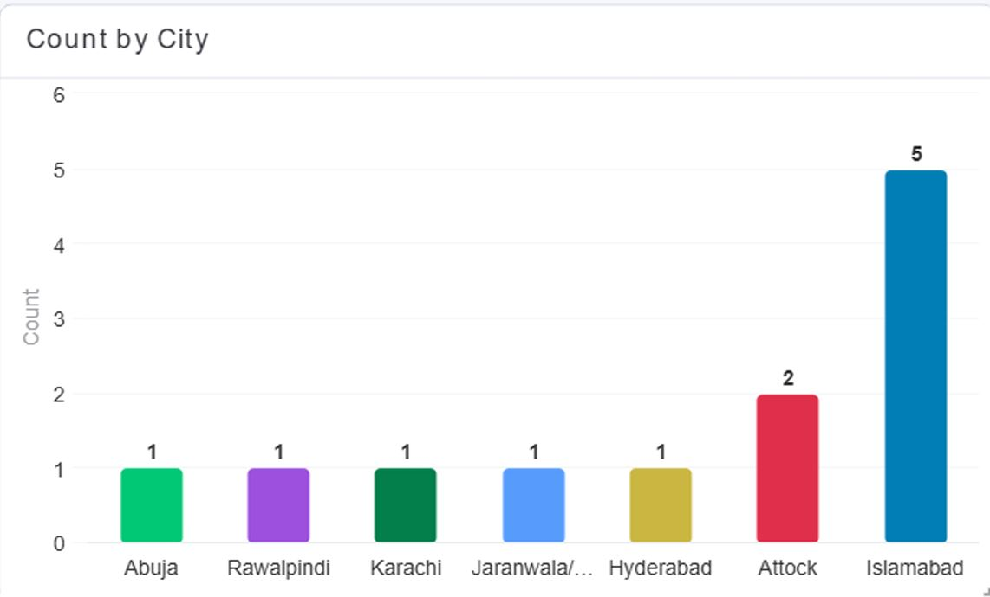

### Student Understand

This pie chart illustrates how well students understood the course material. A majority of participants, 58.3%, felt they understood the material "Very clearly". The remaining 41.7% reported understanding the content "Somewhat".

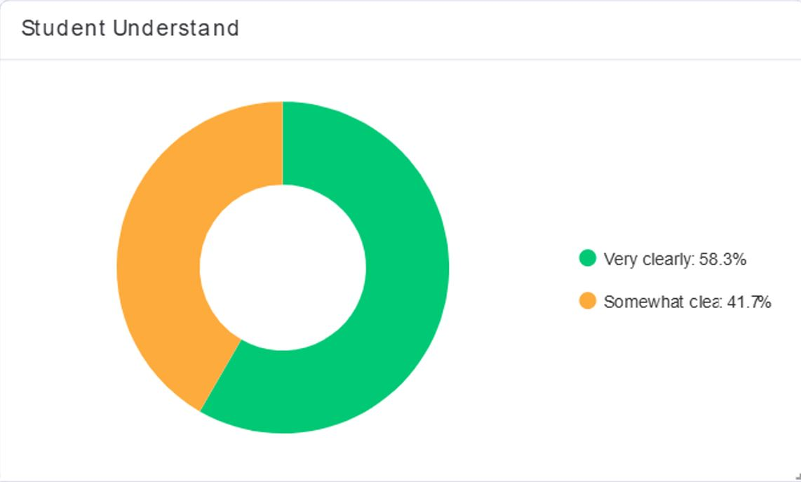

### Country

This pie chart shows the geographic distribution of fellowship participants by country. The vast majority of participants are from Pakistan, accounting for 91.7% of the total. The remaining 8.3% are from Nigeria.

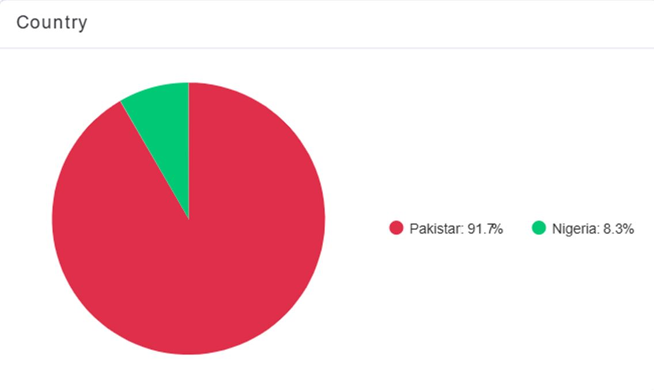

### Facilitator's Clarity and Engagement Rating (Bar Chart)

This bar chart displays participant ratings of the facilitator's clarity and engagement. The ratings are categorized as "Average," "Good," and "Excellent". The highest ratings are "Good" and "Excellent," each with a count of 6.

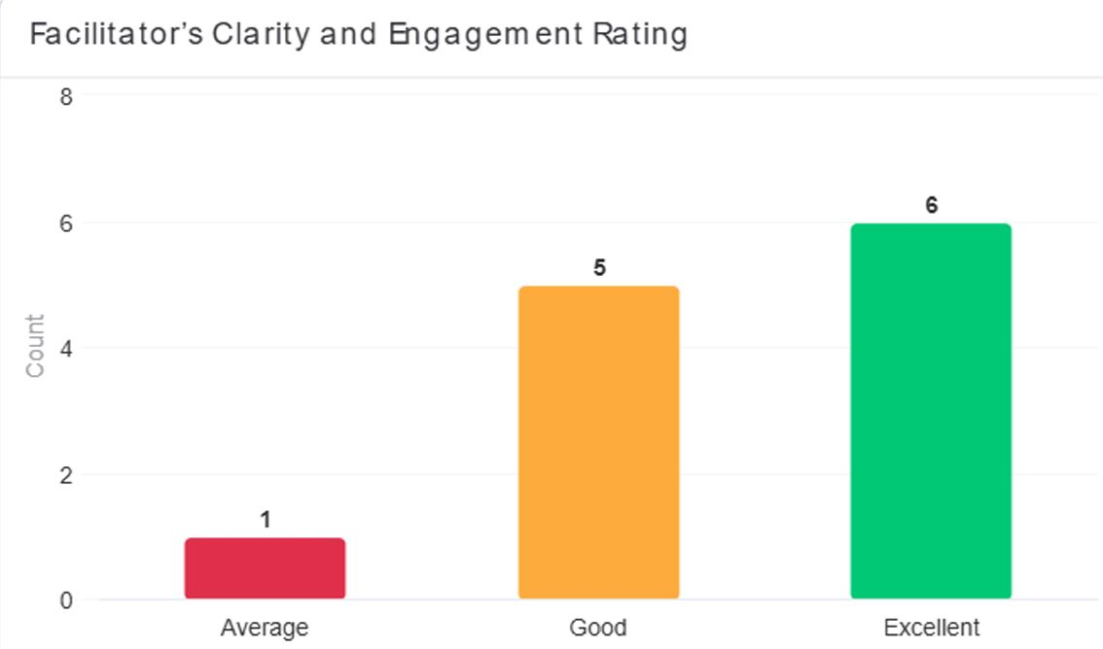

### Facilitator's Clarity and Engagement Rating (Line Chart)

This line graph provides another view of the facilitator's clarity and engagement rating, possibly showing a trend over time or a different data dimension. The y-axis shows the count, and the x-axis has a series of numbers which may represent individual survey responses or time points.

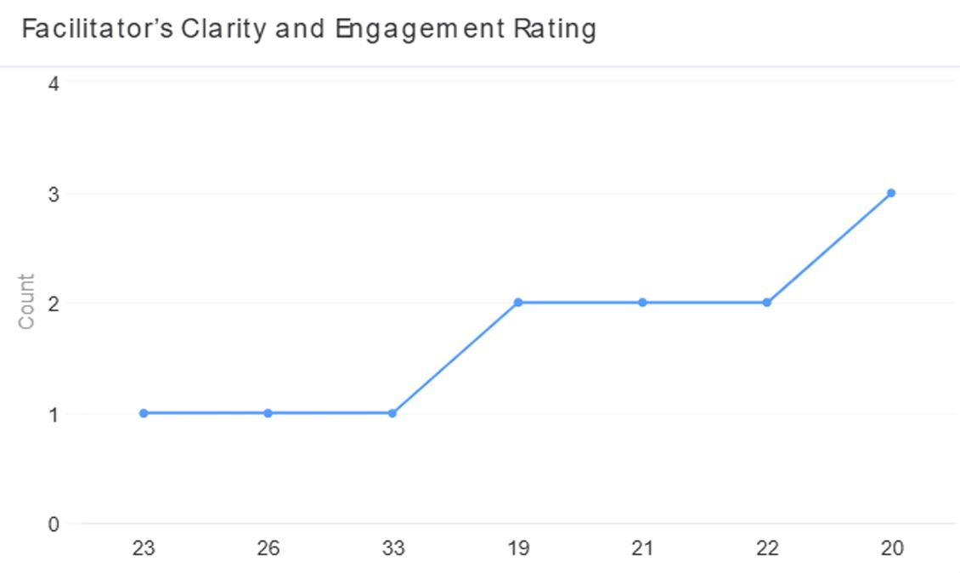

### Male vs Female

This pie chart illustrates the gender distribution of the fellowship participants. The fellowship is predominantly male, with males making up 83.3% of the participants. Females account for the remaining 16.7%.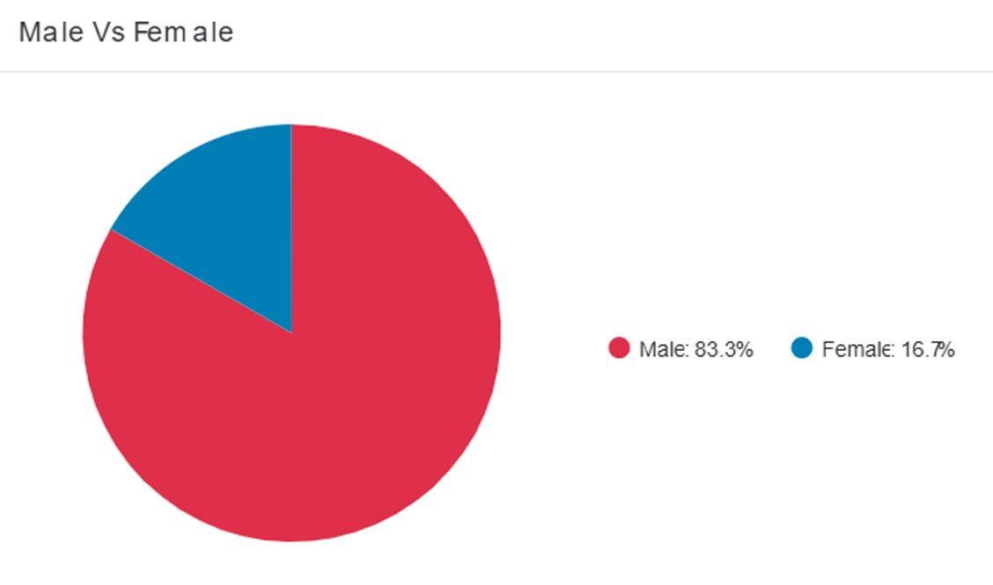

### Learning Activities

This pie chart indicates participant feedback on the learning activities. The data shows that 100% of the participants found the learning activities to be beneficial.

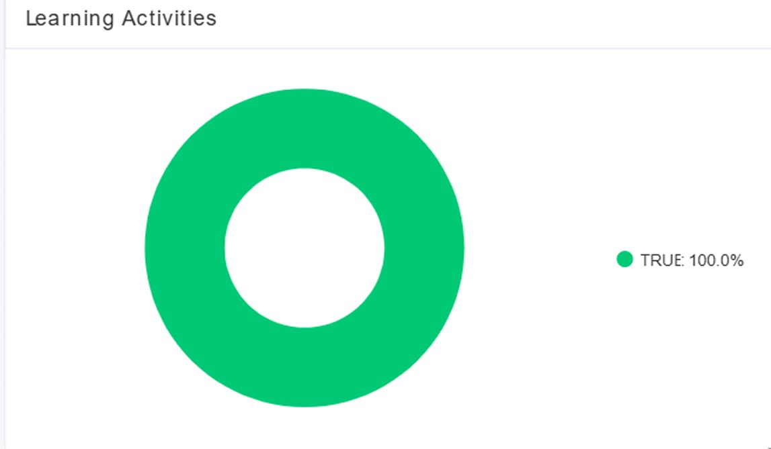

### Student Background

This bar chart displays the academic and professional backgrounds of the participants. The backgrounds are diverse, including Software Engineering and Data Science, which have the highest number of participants with a count of 3 each. Other backgrounds include Computer, Civil Engineering, Informatics, and Mathematics.

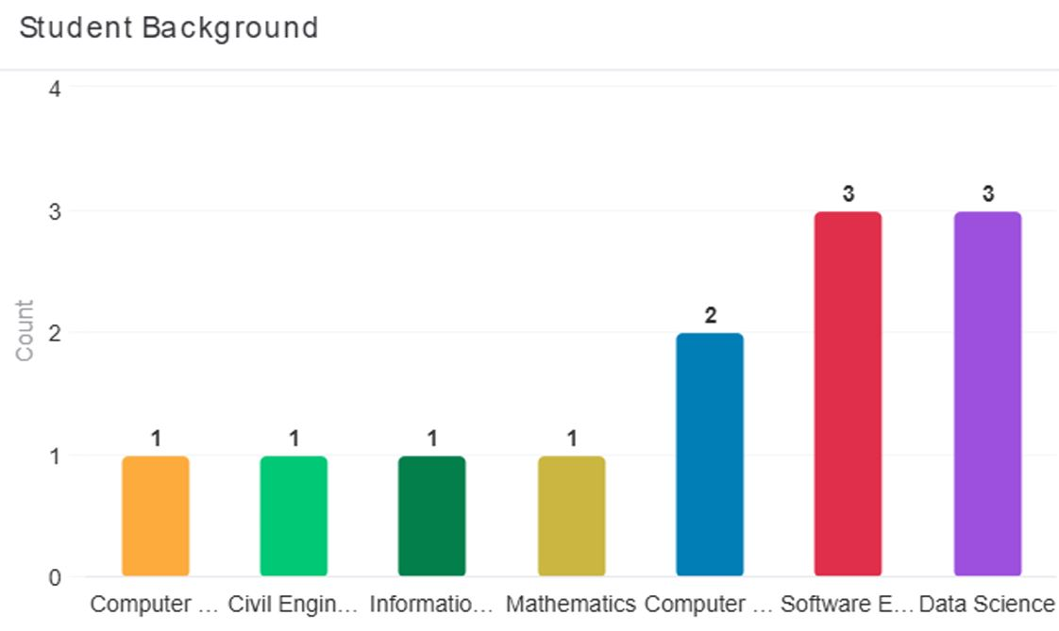

### Insights & Analysis

Based on the dashboard data, here are some key insights:

* **Geographic and Gender Disparity**: The fellowship has a strong concentration in Pakistan, particularly in Islamabad. The program also has a significant gender gap, with male participants vastly outnumbering females at an 83.3% to 16.7% ratio.
* **High Satisfaction and Understanding**: The program is highly effective in its core mission. All participants reported benefiting from the learning activities. A large majority (58.3%) of students found the material "Very clearly" understood, indicating strong curriculum design and delivery.
* **Diverse Academic Backgrounds**: The fellowship successfully attracts individuals from various academic backgrounds, including Software Engineering, Data Science, and Computer Science. This diversity enriches the learning environment and demonstrates the program's broad appeal.

### Recommendations

Based on the analysis, here are some recommendations for future iterations of the program:

* **Expand Geographic Outreach**: To increase diversity, the fellowship should actively market to cities outside of Islamabad and to other countries beyond Pakistan and Nigeria.
* **Address Gender Imbalance**: Implement targeted outreach and scholarship programs to attract more female participants and reduce the significant gender gap.
* **Leverage Facilitator Strengths**: The program should continue to emphasize the facilitator's approach, potentially using their methodology as a model for future facilitators to ensure high-quality delivery.
* **Harness Diverse Backgrounds**: Create opportunities for participants from different academic backgrounds to collaborate on projects. This could help foster a more interdisciplinary learning environment.